Other Preference Tool-Bar Choices

SYSTEM PARAMETERS

The button opens a set of optimization system parameters that configure the optim- ization process at the system level.

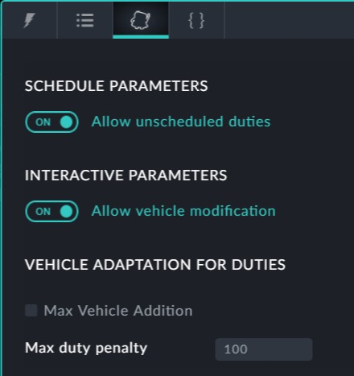

SCHEDULE PARAMETERS

The optimizer may not be able to assign some duties due to restrictive preferences. In such a situation, by setting this switch to ON, the optimizer places the problematic

trips in the editing stack in the Drivers Gantt. The trips may then be investigated for

cause and manually corrected. Otherwise, the optimization will halt will a diagnostic mes- sage.

INTERACTIVE PARAMETERS

The last step of an interactive scheduling session is to Assign Vehicles (see **Completing the Edit Session**).

If this switch is set to ON, vehicle modifications will be allowed during the assign. Other- wise they will not be allowed.

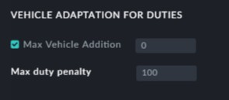

This is used where a Vehicle schedule has been created and the number of assigned

vehicles is acceptable. Changing preferences may assign additional vehicles but real life limitations may make the results untenable.

The **Max Vehicles Addition** is the maximum number of addidional vehicles that can be added after changing preferences and optimizing.

The **Max duty penalty** works in two directions -

It is maximum penalty that can be imposed on a valid duty (in relation to preferences) It is the minimum penalty that is imposed on aninvalid duty (in relation to pref-



erences)

QUICK PREFERENCES

The button opens a set of quick preferences:

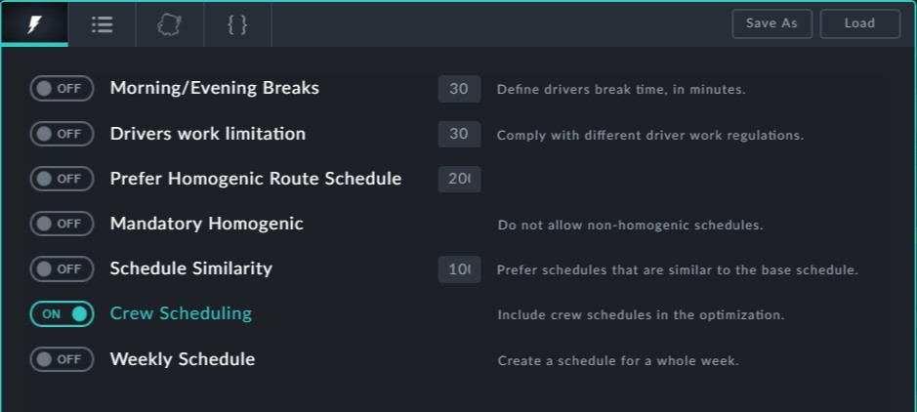

These are frequently used preferences that might be helpful in setting up "What if?" demonstrations.

Clicking the expert mode button shows your preferences in source (JSON) format.



This **Expert** provision also appears at the topic level. It is primarily intended for the use of Optibus Professional Services to -

**Add urgent custom features with a turn around of hours instead of days or weeks. Provide rapid fixes to problems in the field**



It can also be used by customers having the necessary programming expertise. See **Using Expert Mode** for further details.